**How to Install the Spyder IDE on Windows**

Navigate to [SPYDER'S WEBSITE](https://www.spyder-ide.org/) and find the installer.

It's recommended that you install the Anaconda distribution to get Spyder; this distribution contains some useful packages and an environment manager to keep your packages installed and up to date.

Select **Download** from the main menu, and then click on the **Download Spyder with Anaconda** button.

This will take you to a screen where you select your operating system for the installation. Click on the Windows icon.



You'll be asked whether you'd like to download Python 3 or Python 2. We'll go with the latest version of Python (which, as of this writing, is Python 3.7).

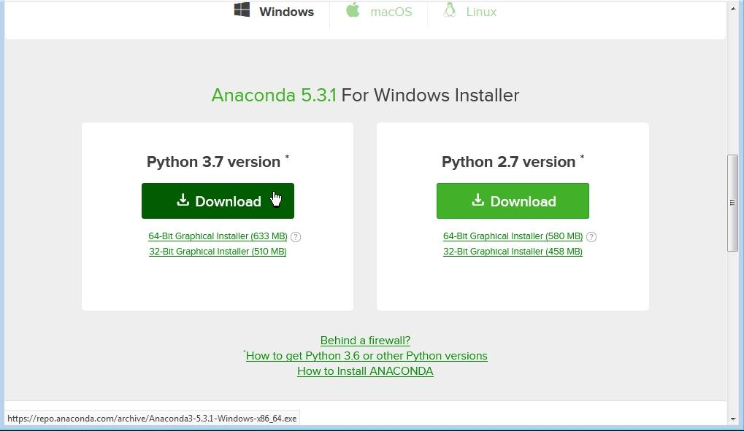

Once the installer has downloaded and you run it, the **Setup** window will display.



Click the **Next** button. In the **License Agreement** window, you'll need to accept the terms by clicking the **I Agree** button.

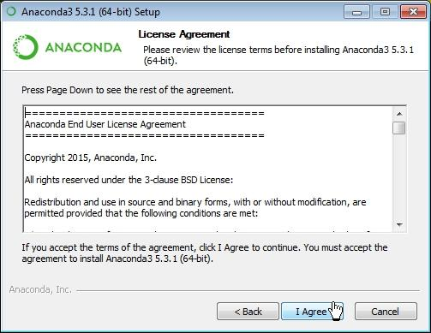

Click **Next** to proceed through the rest of the windows.

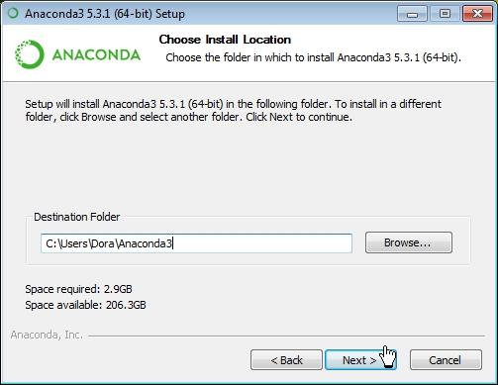

Once you reach the page below, click the **Install** button.

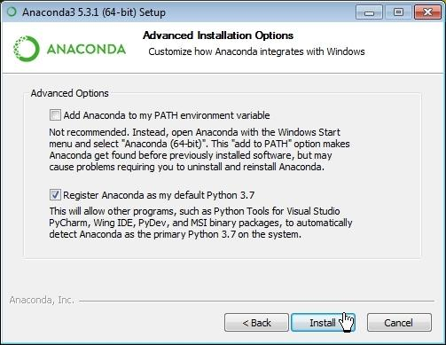

The installation process will begin.

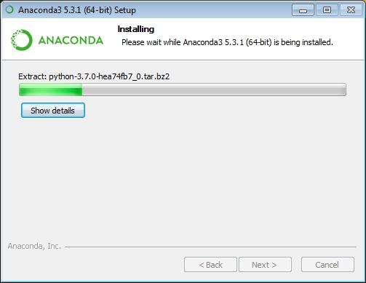

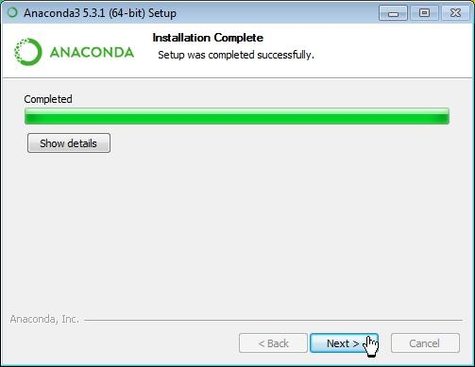

You can download *Visual Studio Code* if you'd like to use it. It's a versatile IDE for developing in a variety of programming languages. We won't install it in this article, though. Click the **Skip** button.



Once the installation is complete, click the **Finish** button.



Afterwards, go to Start › All programs (this is if you're on Windows 7—if you're on Windows 10, press the Windows key and look under Recently added). Select Anaconda Navigator.

You should see a window similar to the one below:

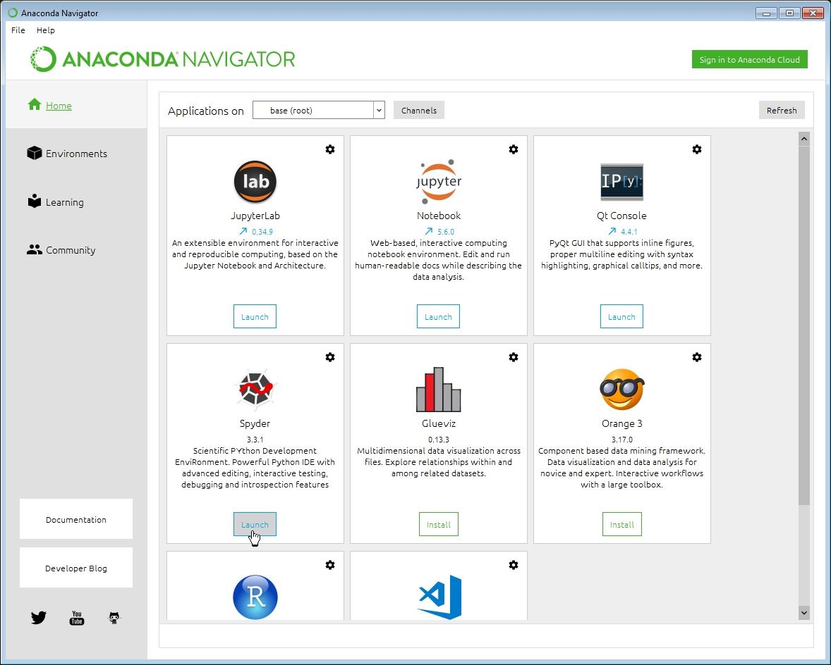

If you'd like run **Spyder**, just click on its **Launch** button. The IDE will open.

